

**Restaurant Manager User Guide**

**What is RManager?**

RManager is a tool for managing bookings in a restaurant environment. It allows staff members to add, edit, remove and view bookings for bookings made on specific times and dates.

Additionally, RManager will provide a tool for the automatic allocation of bookings to their respective tables based on multiple factors.

**Current Progress**

Currently, RManager provides a platform through which restaurant staff can:

1. Create new bookings
2. View previously made bookings
3. Edit previously made bookings (only certain parameters supported)
4. Delete previously made bookings
5. Download a .txt file of previously made bookings based on time/date
6. Query bookings based on name
7. View all bookings in local storage (via admin tools)
8. Clear all local storage (via admin tools)

**Future Development Goals**

RManager is only partially through its development, and thus has several future development goals. Some of these include (in order):

1. Completing modules for allocating tables
2. Allowing administrators more tools for managing staff logins
3. Implementing a more dynamic user interface
   1. **Logging in and Account Creation**

RManager allows for the creation and use of user/staff accounts. These accounts increase the security of the system by reducing the likelihood of an unauthorised person gaining access.

*To create an account*,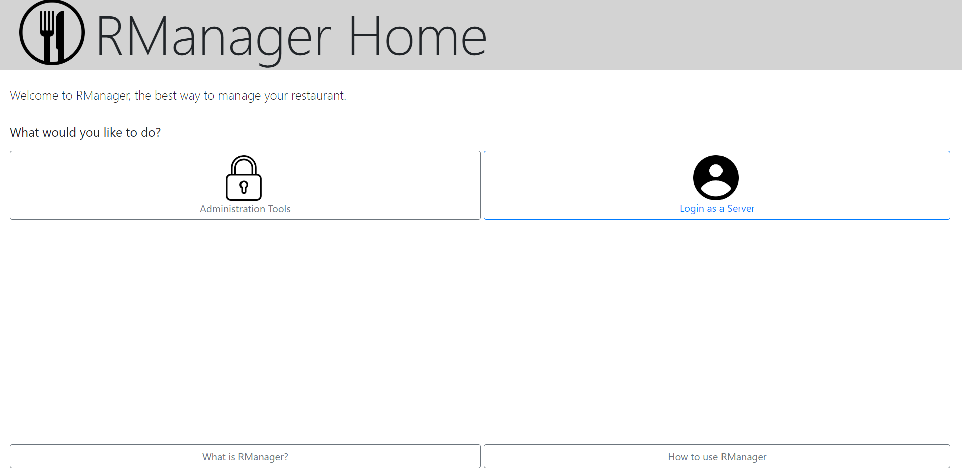 select ‘log on as a server’

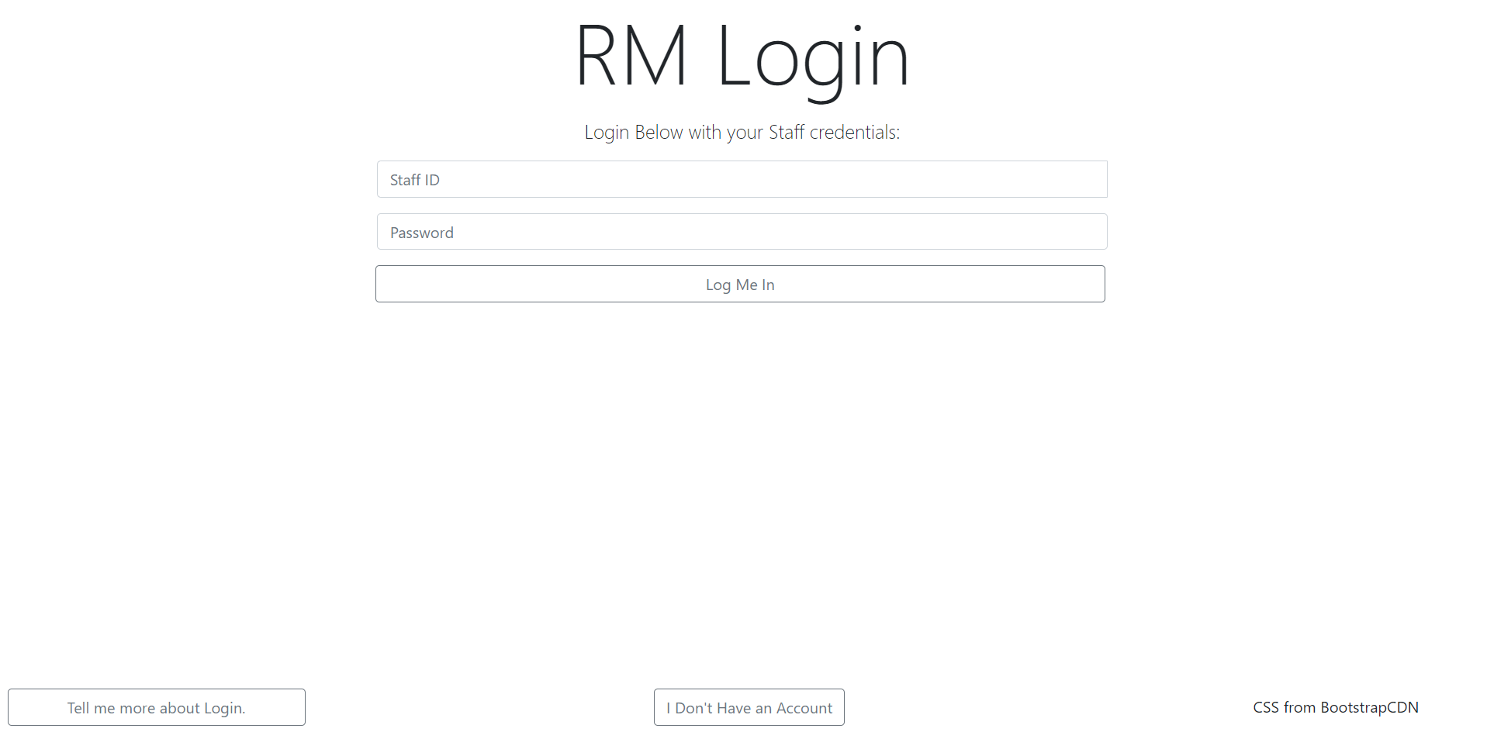Then click ‘I don’t have an account’ at the bottom of the webpage

This will take you to a page where you can create a user account. The page will also let you know if the username is already taken, and will also ensure that data is entered in all fields.

*To log in*, press on ‘log on as a server’

Then, enter your login details in the fields provided.

* 1. **Make a New Booking**